**Assignment 4 (Random State)**

**Name - Chitra Paryani**

**NUID - 001869343**

Please find below screenshot of 6 implementations and test cases in Scala (Random State) Assignment 4:

**Implemented flatMap method:**



**Implemented toStream method:**



**Implemented next, get and map method:**

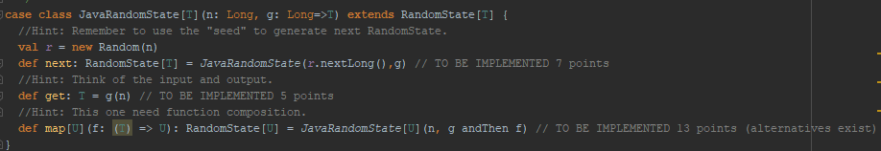

**Implemented longToDouble Value:**



**Screenshot of the Test cases passed:**

